Following are the analytics for the **Kookaburra Men’s Premier Firsts -period 2019/20**

1. Overview of number of matches played by the club players:

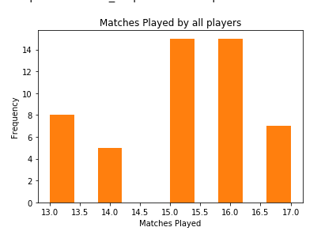

To break down the above chart, matches played by players:

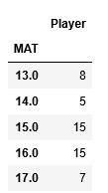

From above figure-7 players played 17 matches they are:

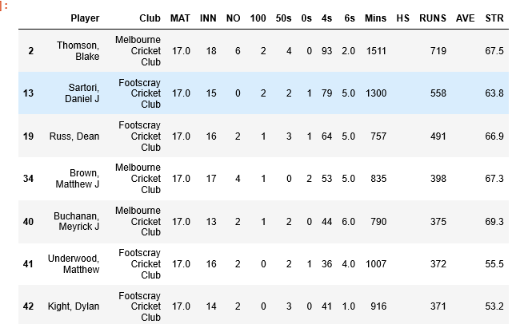

Result: Most of the players played between 15 to 16 matches on average.

1. Comparison of matches and average 6s

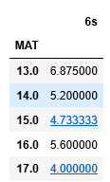

From the above matrix we can see that most 6s is been hit by the players who played 13 matches.

Top three- 6s been hit by the following players:

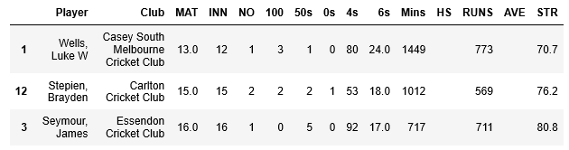

Overview of 6s :

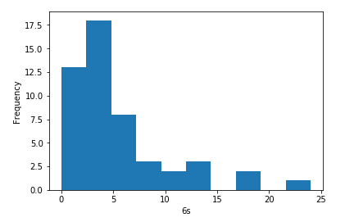 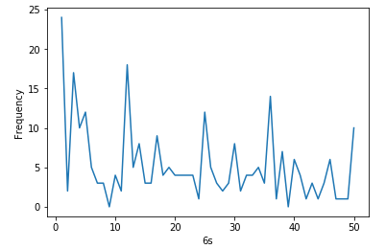

Result : Less than five-6s are most hit by all the players.

1. Compare runs scored and 6s:

Following scatter plot shows runs scored by players according to 6s been hit:

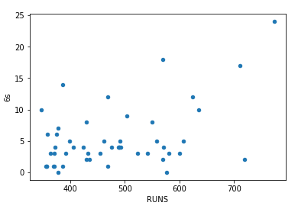

Most number of 6s been hit by players who scored less than and equal to 600 runs.

Top 3 players who scored most runs:

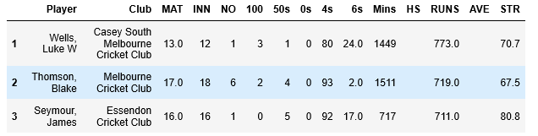

1. 100s scored by all players:

Break down 100s :

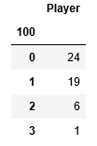

From above matrix : 19 players scored at least one -100s.

Top three-100s scored by:

